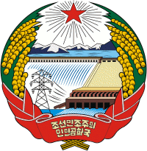

THE EMBASSY OF THE DEMOCRATIC PEOPLE’S REPUBLIC OF KOREA
Norrakungsv.39, 181 31 Lidingö. Tel:+4687673836, Fax:+4687673835, E-mail:koryo@telia.com

Spokesman for KPA General Staff Issues Statement
Pyongyang, October 14 (KCNA) -- A spokesman for the General Staff of the Korean People's Army (KPA) issued the following statement on Oct. 14:
According to a report on enemy movements in the front, the south Korean army conducted an artillery fire for about 10 hours near the forward defence area of the KPA Fifth Corps on Oct. 13.
Taking a serious note of this provocative action by the south Korean military in the frontline area, we took strong military countermeasures.
The KPA sends a stern warning to the south Korean military inciting military tension in the frontline area with reckless action. -0-

